Saturday Science Lesson Plan 1
February 4, 2012

- BIG IDEA or CONCEPTS-LEARNING OBJECTIVES
Students will learn how to make specific, detailed observations about rocks and minerals by practicing making observations around the Jordan River and by observing rock and mineral samples in the classroom.
Students will learn about the texture, shape, and size of different soils and rocks by observing them and using hand lenses to get an up close look.

- STANDARDS
National Standards:
6.4 Earth and Space Science Standards
Levels K-4: Properties of earth materials
Levels K-4: Objects in the sky
Levels K-4: Changes in the earth and sky

Indiana Standards
4.2.2. Describe how wind, water and glacial shape earths land surface by eroding rock and soil in some areas and depositing them in other areas in a process that occurs over a long period of time.
4.2.3. Describe how earthquakes, volcanoes and landslides suddenly change the shape of the land.

- MATERIALS (2 points)

- Text set of about 20 books about the earth (provided by Emma)
- The book for read aloud
- Some form of journal with lined paper in it
- Far out and close up hand outs (attached)
- Magnifying glasses
- Unlined paper
- Pencils and/or colored pencils
- Measuring tape
- Identified rock samples
- PowerPoint of landforms
- Chart paper
- Markers

- TEACHER CONTENT KNOWLEDGE (2 points)

Teacher will need to know when/how to prompt students to make observations on the surrounding landforms. Teacher should be able to gauge the students understanding based on the questions they are asking and comments they may be making. Teacher should know about the soil make up and familiar rocks in the area.
Soil makeup: air, water, minerals, leaves and other forms of broken down organic material.
Surrounding landforms:
Jordan River, open grassy area by the education building
Key Terms:
- Mountain – A large natural elevation of the earth’s surface rising abruptly from the surrounding level; a large steep hill.
- Valley- a low area of land between hills or mountains, typically with a river or stream flowing through it.
- Desert- A dry, barren area of land, especially one covered with sand
- River- A large natural stream of water flowing in a channel to the sea, a lake or another stream.
The difference between valleys and canyons: Canyons have steep, cliff-like walls or sides, whiel valleys have gently sloping sides.

- REFERENCES & HANDOUTS (1 point)

PowerPoint presentation about Mountains, Valleys, rivers and deserts
Attached handouts
- Far out handout for outdoor observation
- Up close handout for rocks
- Up close handout for soil

- DESCRIPTION OF YOUR LESSON (6 points)

9:00-9:30 Early bird engagement: students will have time to look over several books that are part of a text set about the earth that are set at each table until everyone arrives.
9:30-9:45 Book read aloud
9:45-9:50 write down 2 questions about the book
9:50-10:00 Split into 2 groups, pass out handouts and go outside
10:00-10:15 Make observations, fill out hand out and collect samples at site 1
10:15-10:30 Make observations, fill out hand out and collect samples at site 2
10:30-10:35 come inside
10:35-10:45 fill out soil observation “up close” handout
10:45-11:05 fill out rock observation “up close handout
11:05-11:15 Break/Snack
11:15-11:30 view PowerPoint of mountains, valleys, deserts and rivers. Make collaborative lists on chart paper
11:30-12:00 Listen to student’s questions and note them down. Have discussion about their questions. Listen to each other’s questions. Explain to them the concept of rock and minerals, and tell them that next week, we will be focusing on the questions related to rocks and minerals.

ENGAGE
- Seat students where their folders are located after they sign in.
- Students that arrive early will be instructed to look over the books at their table until class starts. Each table will have folders at it, students will find their folder. Group’s seated by grade level.
- At 9:30 I will do a read aloud of pages 5-7 from A Handful of Dirt by Raymond Bial.
Who can tell me some of the things that make up soil?
Broken pieces of rock, sand, rotted leaves, grass and dead insects.
Who benefits from the soil?
Plants, vegetables, trees, people, animals, earthworms and bacteria
How do people benefit from soil?
Helps plants live which provide oxygen, products like cotton and wool.
- When the book is over, the students will write 2 questions they have in their notebooks.
- I will then pass out the observation “far out” handouts to each student and we will split up into 2 groups. The focus of each handout is observations from each site handout.
- I will explain what a geologist is (scientists that study the earth) and instruct them to act as geologists and make careful observations of the earth surface when they are outside.
EXPLORE
- Once outside the students will be at 2 sites. Site 1- The Jordan River. Site 2- the grassy area across from the library.
- At each site the students will have 15 minutes to make observations, fill out their “far out” handouts and collect a sample. At site 1, the sample to collect will be a rock or pebble. At site 2 it will be a soil sample.
- After 15 minutes the two groups will switch sites.
- After each group has had 15 minutes at each site, we will all come back inside and there will be a short period for any students that need to complete their handouts.
- The students will then pour their soil samples out onto white computer paper and observe the soil samples with a magnifying glass.
- The students will fill out an “up close” handout about their soil observations
- The students will fill out an “up close” handout about their rock observations.
- Let the students finish rock and soil observations on their handout and then we will let them move in group of four or pairs around the room to make observations of rocks and compare with their samples.
- There will be several identified types of rock samples around the room. As part of the up close rock observation the students will compare the rock sample they gathered to the identified rocks and compare them. Students will make note of similarities and differences in the color, shape and size of their rocks and write it down in their science journals.

EXPLAIN
Start with the discussion of what they observed outside and in the classroom. Note these observations on the board or chart paper.
- After the break, students will view a PowerPoint with several landforms on it to introduce them to 4 main landforms; Mountain, valley, river and desert. Each landform will be represented in several diverse examples. The class will make observations about each landform
- For each landform we will make a collaborative list of similarities between examples on chart paper.
- Who can, in your own words, describe what this landform is?
- Who can tell me some defining features?
- What kinds of samples would we collect from this landform?
- After all 4 landforms are covered students will write in their journals 2 more questions.

ELABORATION
- Show Bill Nye clip starting at 2:50
  - http://www.youtube.com/watch?v=8ktq4aa-Sh4
- In their science journals ask the students to write:
- Two things that they learned today that they found especially interesting that they can teach the person that is coming to pick them up.
- At least one question they still have.

Name_______________________________________________________
Far out observations (grassy area)

What features or characteristics do you notice in this area?
________________________________________________________________________________________________________________________________________________________________________________________________________________________________________________________________________________________________________________________
Are there any characteristics that resemble?
A dip in the land?
______________________________________________________________________________
Hills? ______________________________________________________________________________
Dry, dead area? ______________________________________________________________________________
Wet, flowing water? ______________________________________________________________________________
Write at least one question about this outdoor experience:
__________________________________________________________________________________________________________________________________________________________________________________________________________________________________________
______________________________________________________________________________

On the back, draw your surrounding area below and then collect your sample of SOIL.
Name_______________________________________________________
Far out observations (Jordan River) 

What features or characteristics do you notice in this area?
________________________________________________________________________________________________________________________________________________________________________________________________________________________________________________________________________________________________________________________
Are there any characteristics that resemble :
A dip in the land? ______________________________________________________________________________
Hills? ______________________________________________________________________________
Dry, dead area? ______________________________________________________________________________
Wet, flowing water? ______________________________________________________________________________
Write at least one question about this outdoor experience:
________________________________________________________________________________________________________________________________________________________________________________________________________________________________________________________________________________________________________________________

On the back, draw your surrounding area below and then collect your ROCK sample.
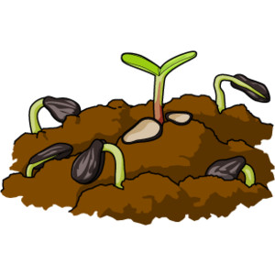 Name_____________________________________________
Soil Up Close

Where did you collect your soil sample?
__________________________________________________________________________________________________________________________________________________________________________________________________________________________________________
Describe the environment around the soil.
_______________________________________________________________________________________________________________________________________________________________________________________________________________________________________________________________________________________________________________________
How does the soil feel?
______________________________________________________________________________
Is there anything besides soil in your sample? If so, what? ______________________________________________________________________________________________________________________________________________________________________________________________________________________________________________________________________________________________________________________
Write at least one question you have about soil:
__________________________________________________________________________________________________________________________________________________________________________________________________________________________________________
On the back draw what your soil looks like with your eyes, and when observed under a magnifying glass.

Rock Up Close

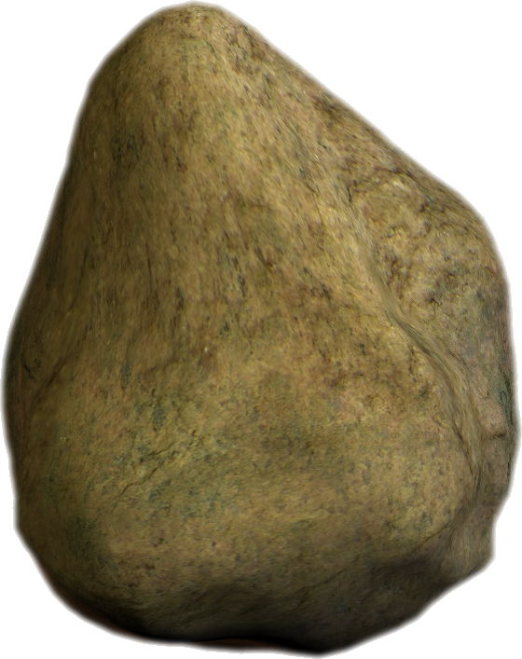
Name:_______________________________________________________

Where did you collect your rock sample? Describe the habitat.
__________________________________________________________________________________________________________________________________________________________________________________________________________________________________________
What kinds of other rocks did you see in the area?
__________________________________________________________________________________________________________________________________________________________________________________________________________________________________________
How does the rock feel? ______________________________________________________________________________
What color is the rock? ______________________________________________________________________________
Is your rock shiny or dull? ______________________________________________________________________________
How tall is your rock? (Measure in centimeters)
______________________________________________________________________________
How long is your rock? (Measure in centimeters)
______________________________________________________________________________
Write at least one question you have about rocks: ____________________________________________________________________________________________________________________________________________________________
On the back, draw what you think your soil looks like with your eyes, and when observed under a magnifying glass.

